Pinni Venkata Abhiram

20BAI1132

CSE3002 – Internet and Web Programming

Lab – 10

Question – 1

Display the content of the text file in the browser which is available in server using jquery.

HTML Code

<!DOCTYPE html>

<html lang="en">

<head>

    <meta charset="UTF-8">

    <meta http-equiv="X-UA-Compatible" content="IE=edge">

    <meta name="viewport" content="width=device-width, initial-scale=1.0">

    <title>PHP thing</title>

</head>

<body>

    <div style="margin: 50px; border: 1px solid; padding: 40px;">

        <h1>Ajax Exercise Lab - 10</h1><br><br>

        <button class = "button"> Click this to view A text file </button><br><br>

        <p class="p1" style="font-size: 20px;"></p><br><br>

        <br><br>

        <p class="p2" style="font-size: 20px;"></p><br><br>

    </div>

    <script src="https://ajax.googleapis.com/ajax/libs/jquery/3.5.1/jquery.min.js"></script>

    <script src="index2.js"></script>

</body>

</html>

JS Code

$(".button").click(function(){

    $.get("ab.txt", function(data){

      $(".p1").text(data);

    });

});

Text file Content

The legal system is made up of civil courts, criminal courts and specialty courts, such as family law courts and bankruptcy courts. Each court has its own jurisdiction, which refers to the cases that the court is allowed to hear. In some instances, a case can only be heard in one type of court. For example, a bankruptcy case must be heard in a bankruptcy court. In other instances, more than one court could potentially have jurisdiction. For example, a federal criminal court and a state criminal court would each have jurisdiction over a crime that is a federal drug offense but that is also a state offense.

Output

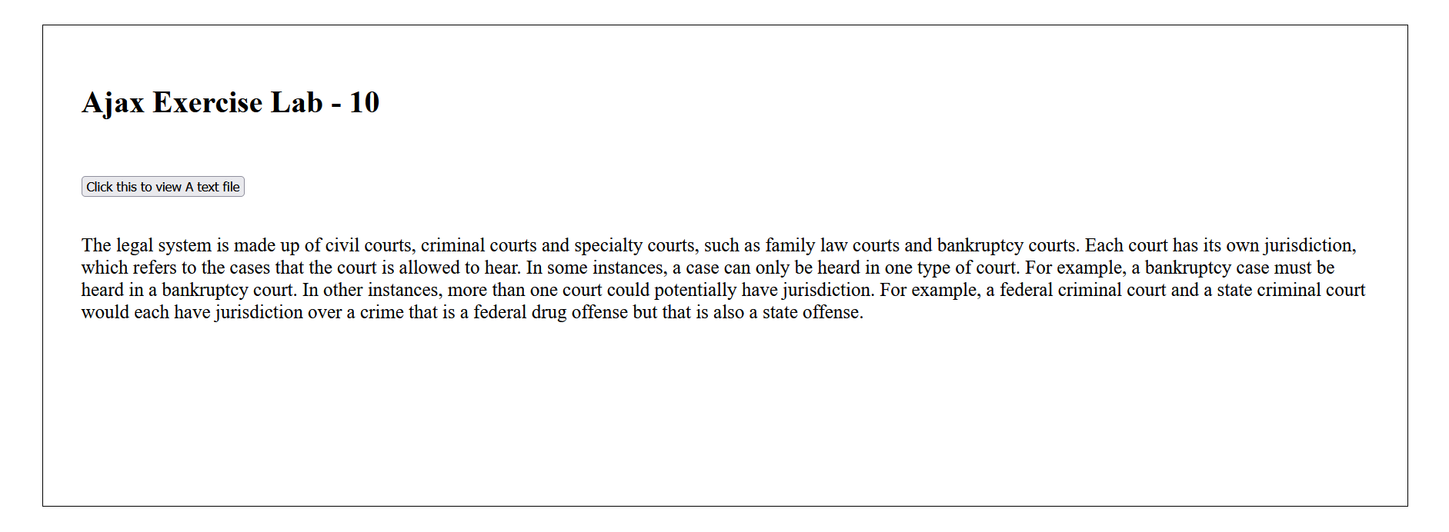

Question – 2

Display the content of php file in the browser which is available in server using jQuery.

HTML Code

<!DOCTYPE html>

<html lang="en">

<head>

    <meta charset="UTF-8">

    <meta http-equiv="X-UA-Compatible" content="IE=edge">

    <meta name="viewport" content="width=device-width, initial-scale=1.0">

    <title>PHP thing</title>

</head>

<body>

    <div style="margin: 50px; border: 1px solid; padding: 40px;">

        <h1>Ajax Exercise Lab - 10</h1><br><br>

        <button class="button"> Click this to view A PHP File </button><br><br>

        <p class="p1" style="font-size: 20px;"></p><br><br>

    </div>

    <script src="https://ajax.googleapis.com/ajax/libs/jquery/3.5.1/jquery.min.js"></script>

    <script src="index3.js"></script>

</body>

</html>

JS Code

$(".button").click(function(){

    $.get("s.php", function(data){

      $(".p1").text(data);

    });

});

PHP Code

<?php

    echo "The legal system is made up of criminal and civil courts and specialty courts like bankruptcy and family law courts. Each court is vested with its own jurisdiction. Jurisdiction refers to the types of cases the court is permitted to rule on. Sometimes, only one type of court can hear a particular case. For instance, bankruptcy cases can be ruled on only in bankruptcy court. In other situations, it is possible for more than one court to have jurisdiction. For instance, both a state and federal criminal court could have authority over a criminal case that is also considered an offense under federal and state drug

     laws."

?>

Output

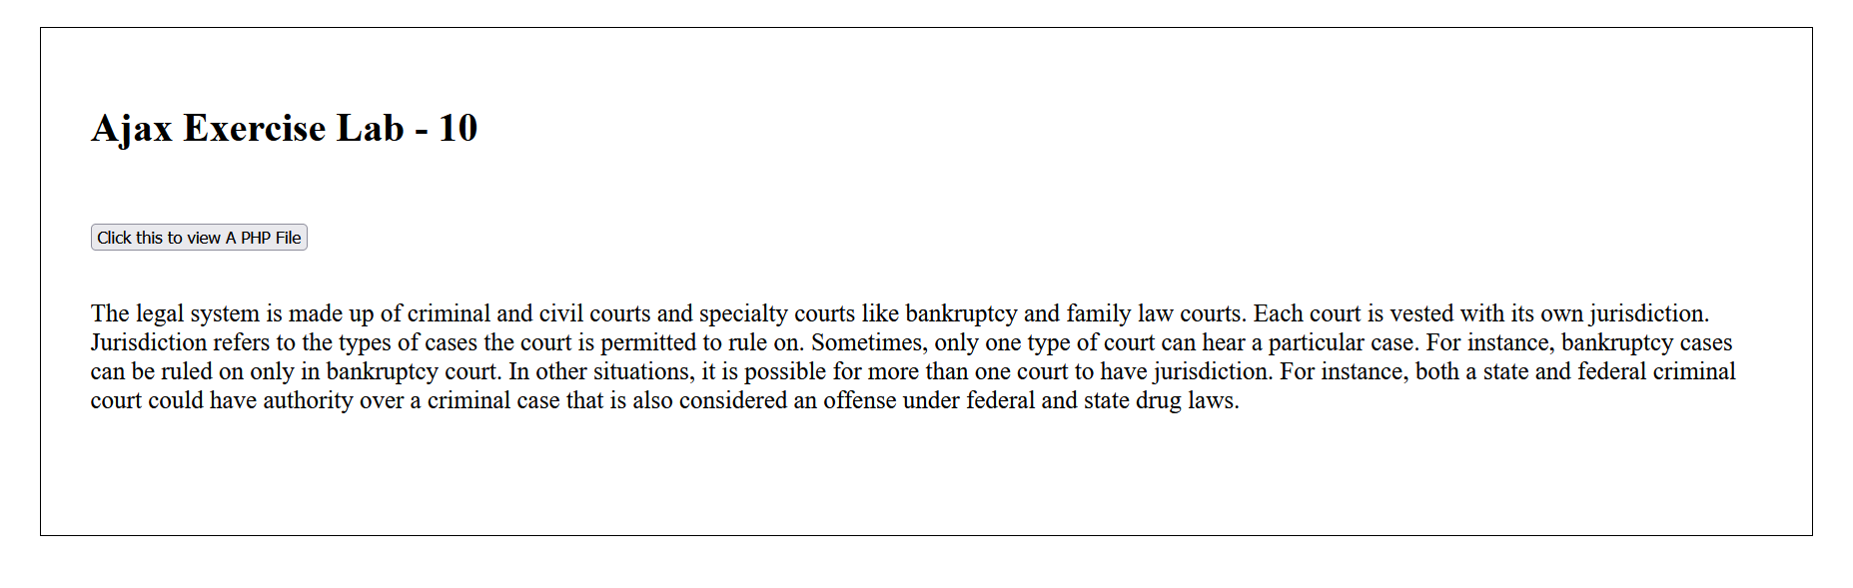

Question – 3

English teacher has given a written assignment to the students and two students submitted their assignments as text files in server. Assume that the teacher would like to calculate the plagiarism between two these text files of 100 words length which is stored in server. Implement the minimal webapplication using jquery to calculate the plagiarism in %. ((similar number of words/ total number of  words) \*100) and display the same in  a message box.

HTML Code

<!DOCTYPE html>

<html lang="en">

<head>

    <meta charset="UTF-8">

    <meta http-equiv="X-UA-Compatible" content="IE=edge">

    <meta name="viewport" content="width=device-width, initial-scale=1.0">

    <title>PHP thing</title>

</head>

<body>

    <div style="margin: 50px; border: 1px solid; padding: 40px;">

        <h1>Ajax Exercise Lab - 10</h1><br><br>

        <button onclick = "abc()"> Click this to view A file </button><br><br>

        <p class="p1" style="font-size: 20px;"></p><br><br>

        <button onclick = "def()"> Click this to view B file </button><br><br>

        <p class="p2" style="font-size: 20px;"></p>

        <br><br>

        <button onclick = "ans()"> Check your Plagerism </button><br><br>

        <p class="p3" style="font-size: 20px;"></p>

    </div>

    <script src="index.js"></script>

</body>

</html>

JS Code

function abc()

{

    var xhttp = new XMLHttpRequest();

    xhttp.onreadystatechange = function()

    {

        if (xhttp.readyState == 4 && xhttp.status == 200){

            document.querySelector(".p1").innerHTML = xhttp.responseText;

        }

    }

    xhttp.open("GET","ab.txt",true);

    xhttp.send();

}

function def() {

    var xhttp = new XMLHttpRequest();

    xhttp.onreadystatechange = function()

    {

        if (xhttp.readyState == 4 && xhttp.status == 200){

            document.querySelector(".p2").innerHTML = xhttp.responseText;

        }

    }

    xhttp.open("GET","ba.txt",true);

    xhttp.send();

}

function ans()

{

    var count = 0;

    var str = document.querySelector('.p1').textContent;

    var str2 = document.querySelector('.p2').textContent;

    var words = str.split(" ");

    var words2 = str2.split(" ");

    for (var i = 0 ; i < words.length ; i++)

    {

        for (var j = 0 ; j < words2.length ; j++)

        {

            if (words[i].toLowerCase() === words2[j].toLowerCase())

            {

                count++;

            }

        }

    }

    var tot = words.length + words2.length;

    var ans = (count / tot)\*100;

    document.querySelector('.p3').innerHTML = "The final plagerism percent is : " + ans;

}

Text file one content

The legal system is made up of civil courts, criminal courts and specialty courts, such as family law courts and bankruptcy courts. Each court has its own jurisdiction, which refers to the cases that the court is allowed to hear. In some instances, a case can only be heard in one type of court. For example, a bankruptcy case must be heard in a bankruptcy court. In other instances, more than one court could potentially have jurisdiction. For example, a federal criminal court and a state criminal court would each have jurisdiction over a crime that is a federal drug offense but that is also a state offense.

Text file two content

The legal system is made up of criminal and civil courts and specialty courts like bankruptcy and family law courts. Each court is vested with its own jurisdiction. Jurisdiction refers to the types of cases the court is permitted to rule on. Sometimes, only one type of court can hear a particular case. For instance, bankruptcy cases can be ruled on only in bankruptcy court. In other situations, it is possible for more than one court to have jurisdiction. For instance, both a state and federal criminal court could have authority over a criminal case that is also considered an offense under federal and state drug laws.

Output

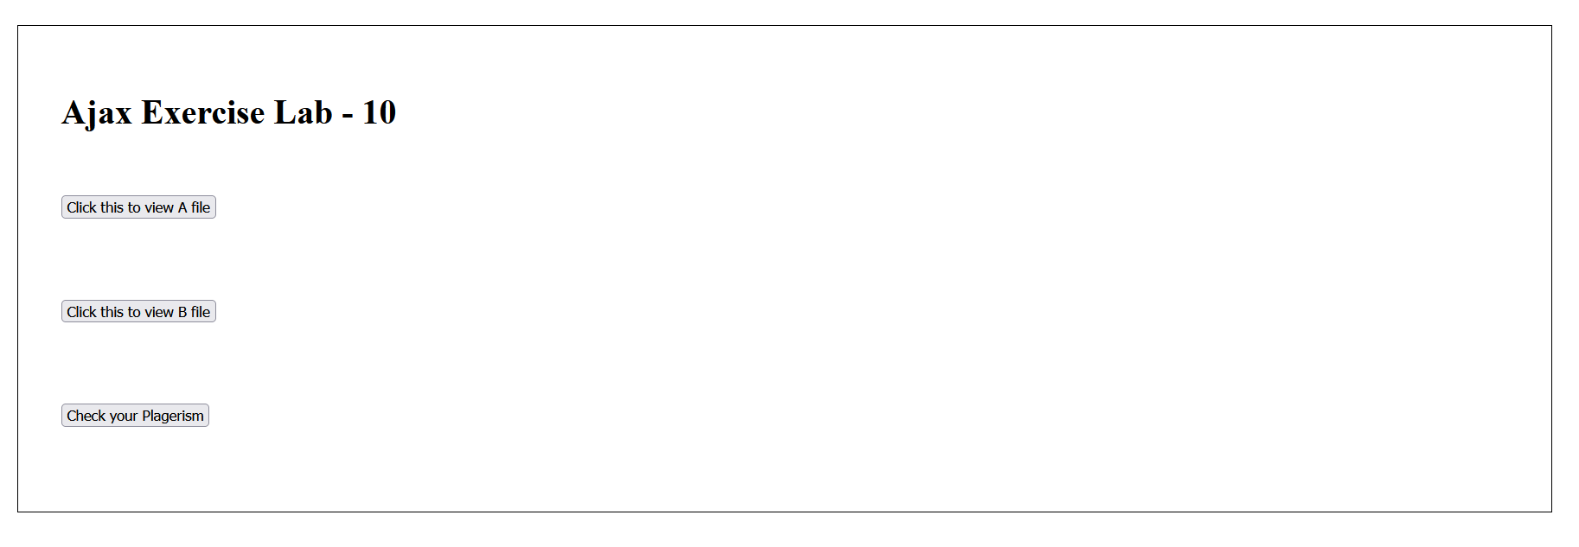

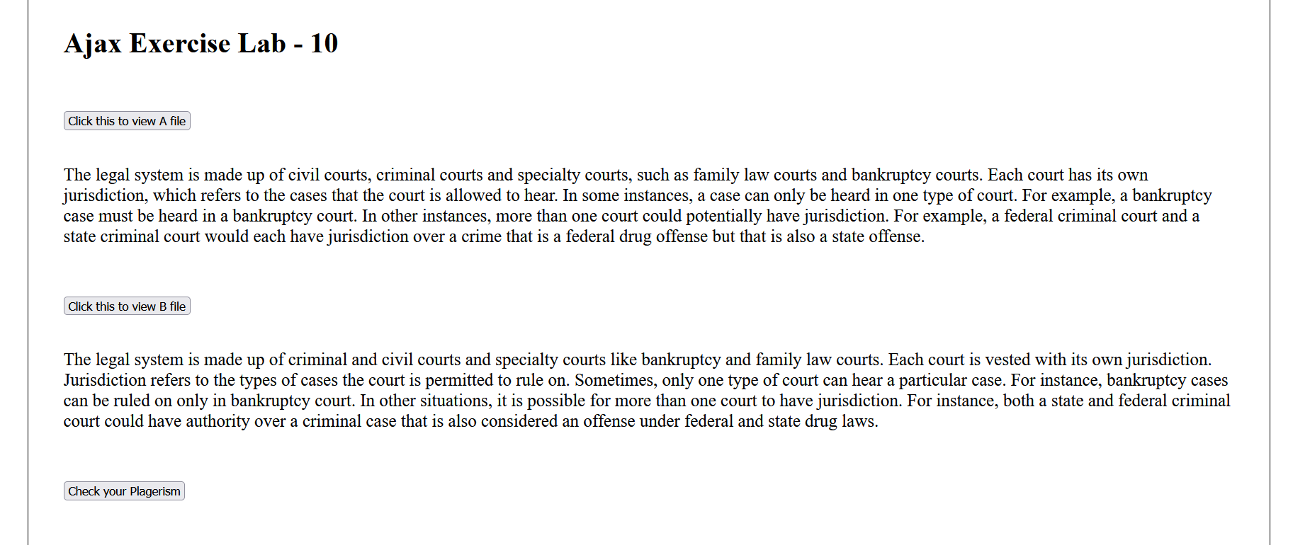

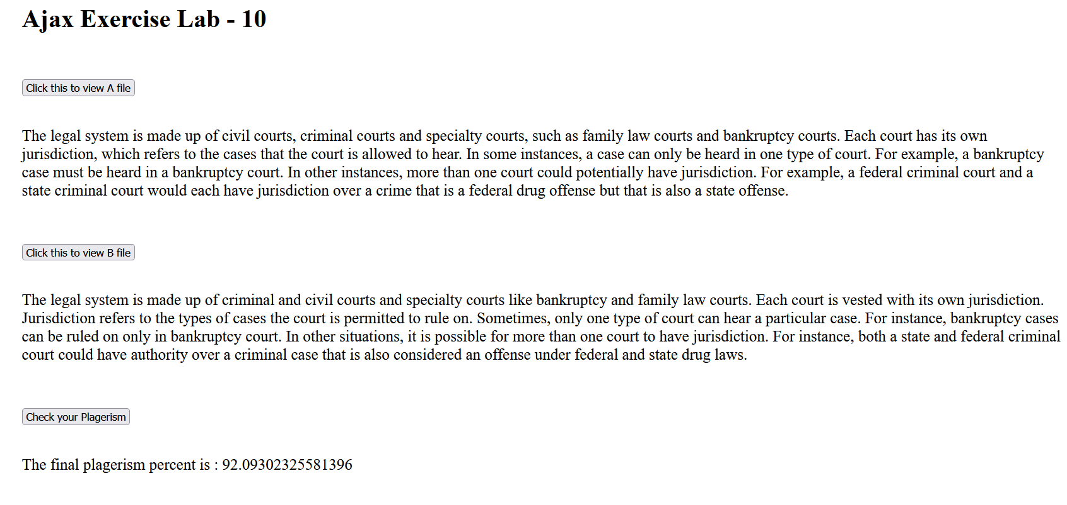

Thank you ma’am , Pinni Venkata Abhiram 20BAI1132